**SITEMAP**

* This is the planning that went behind the creation of the website. The Entity Relationship Diagram and Relation Schema which were first drafted before any coding was started. This enabled us to get a clear picture of the task at hand and what would be required.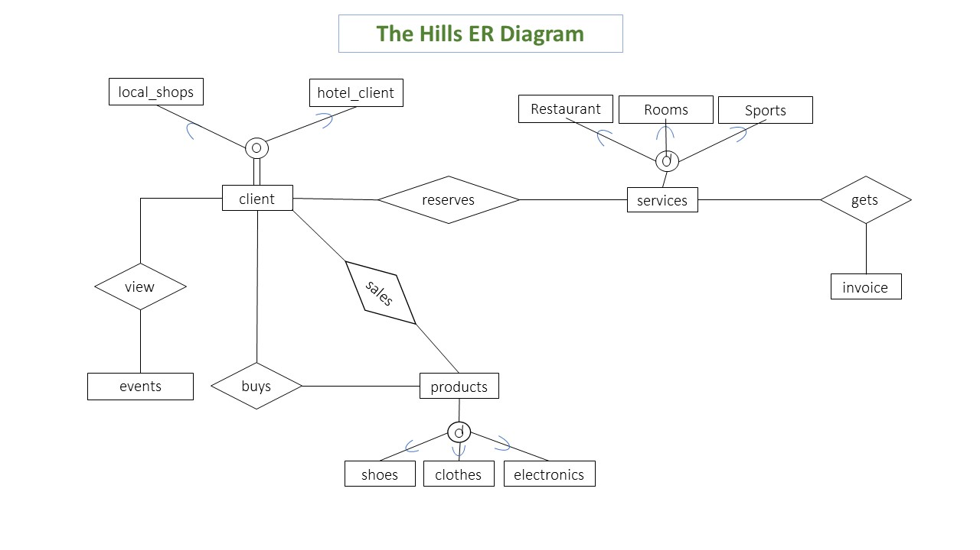

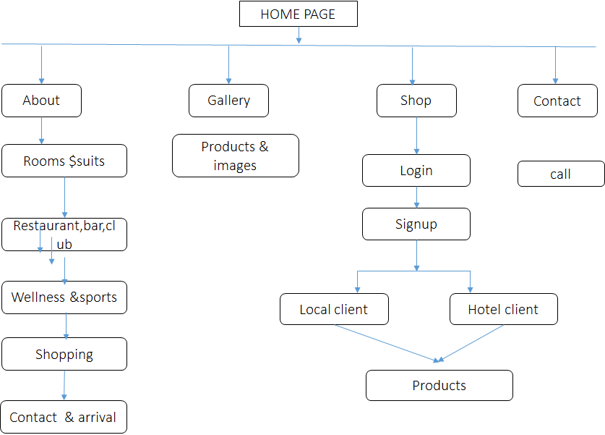

* When the coding eventually began, the first pages to be created were those of the hotel; the home page where the booking takes place, the rooms, restaurants,

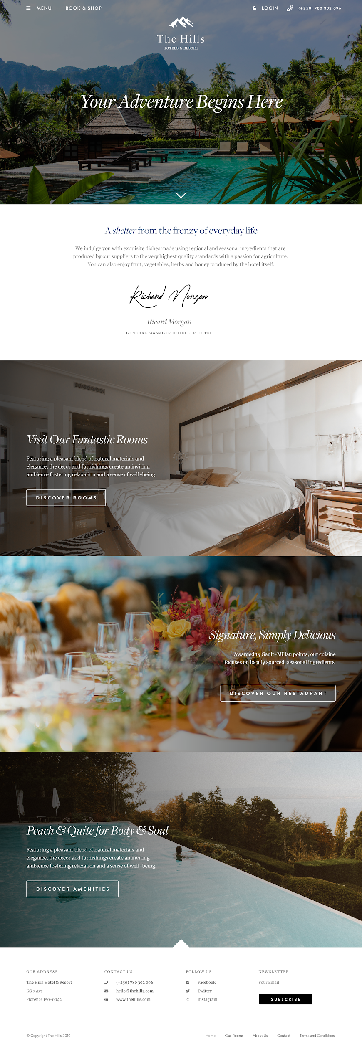



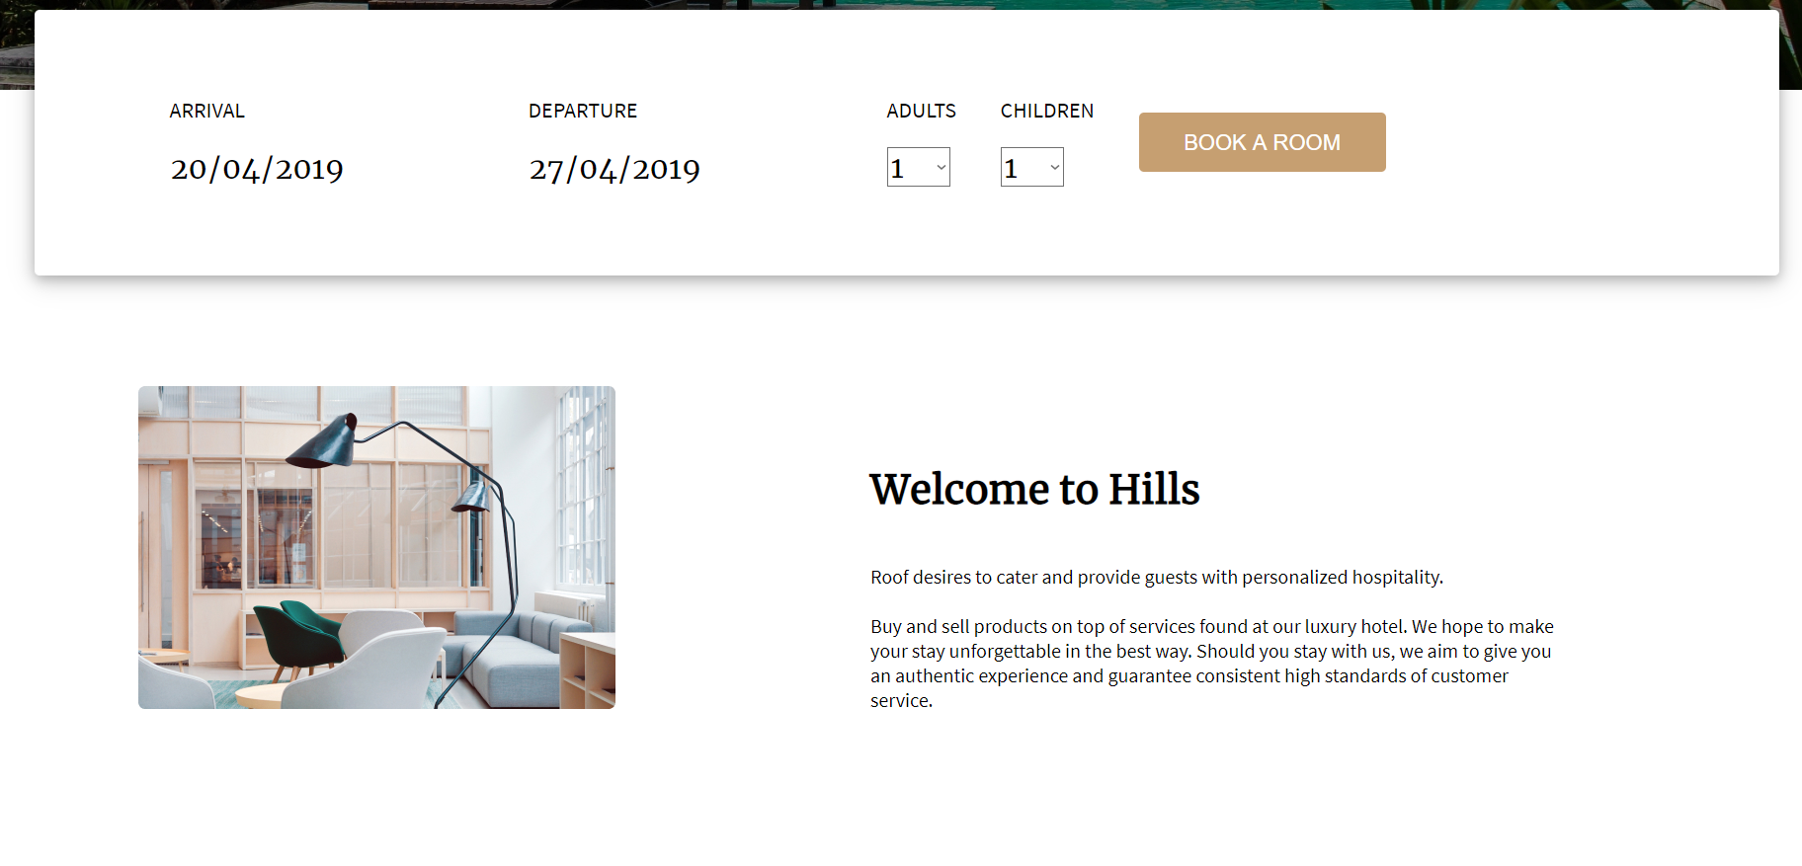

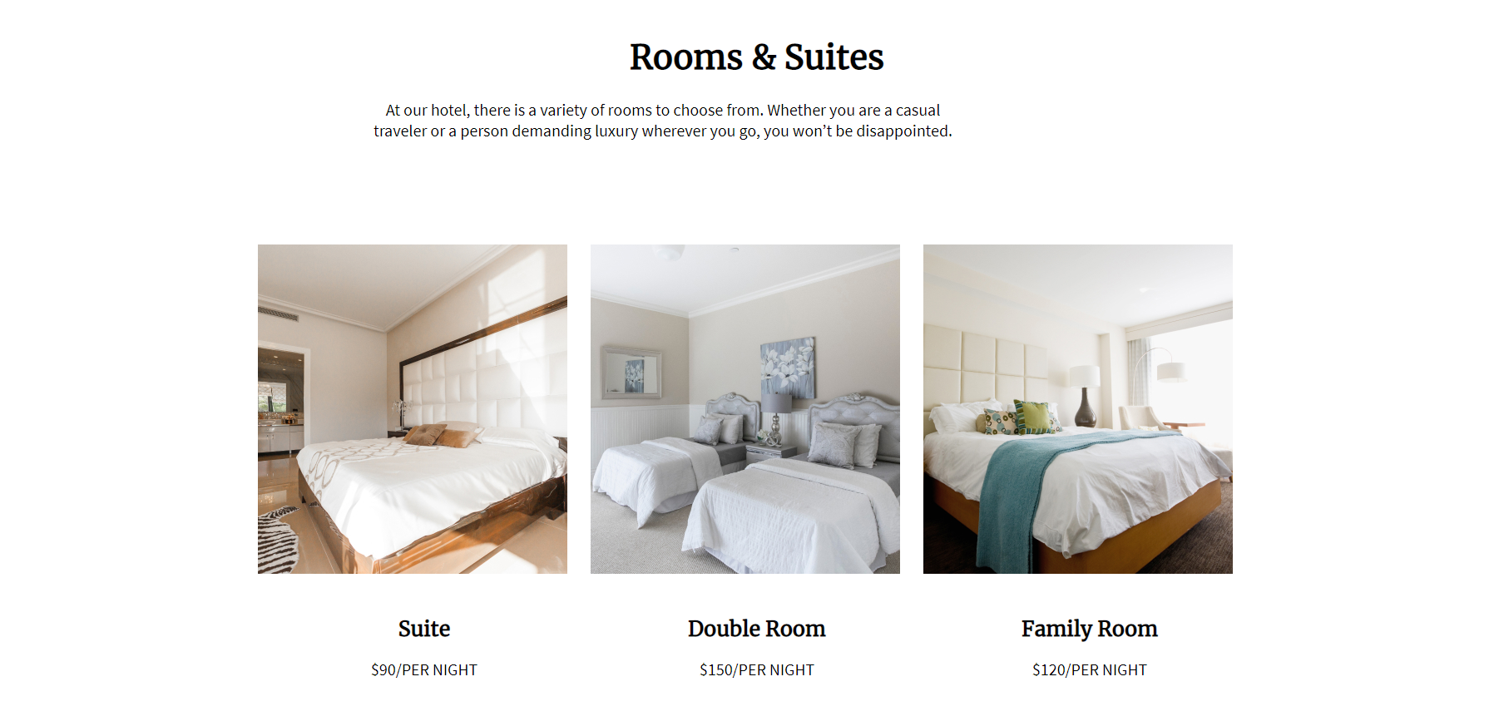

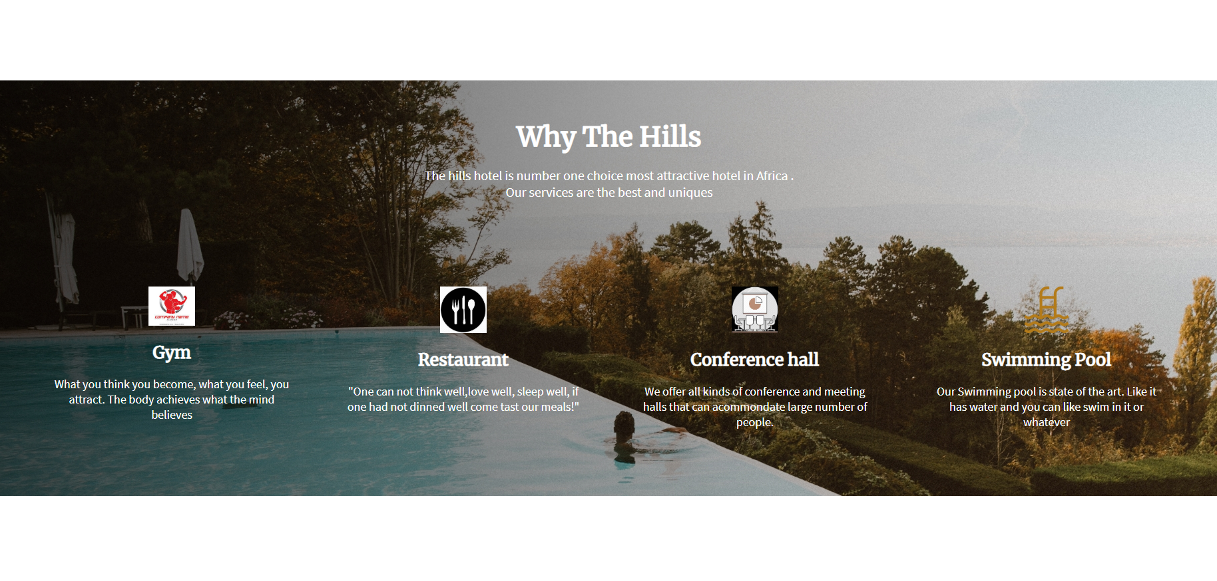

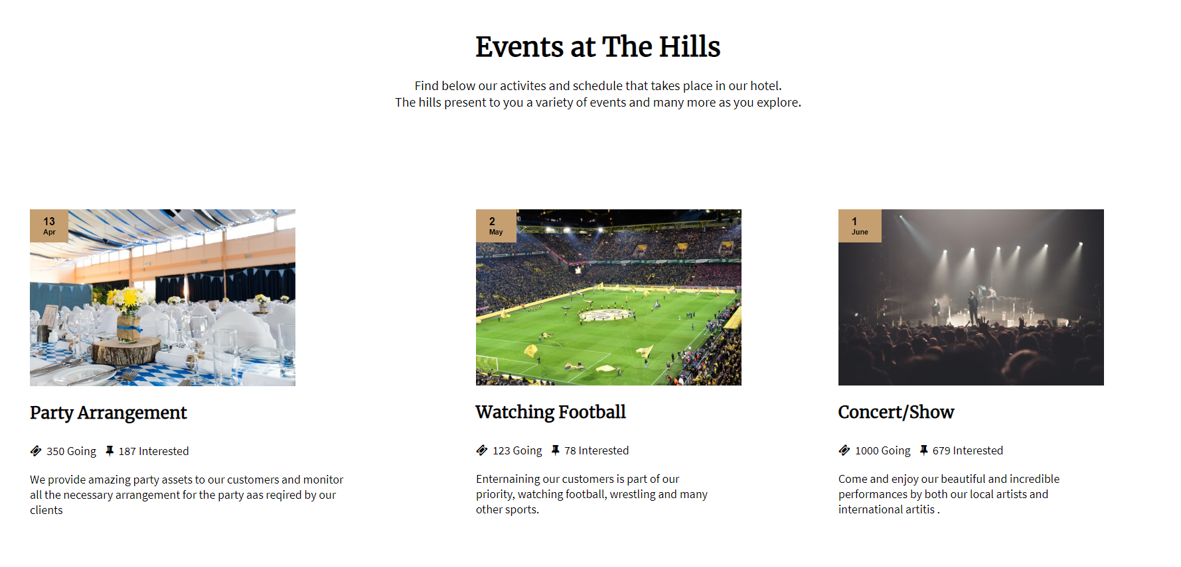

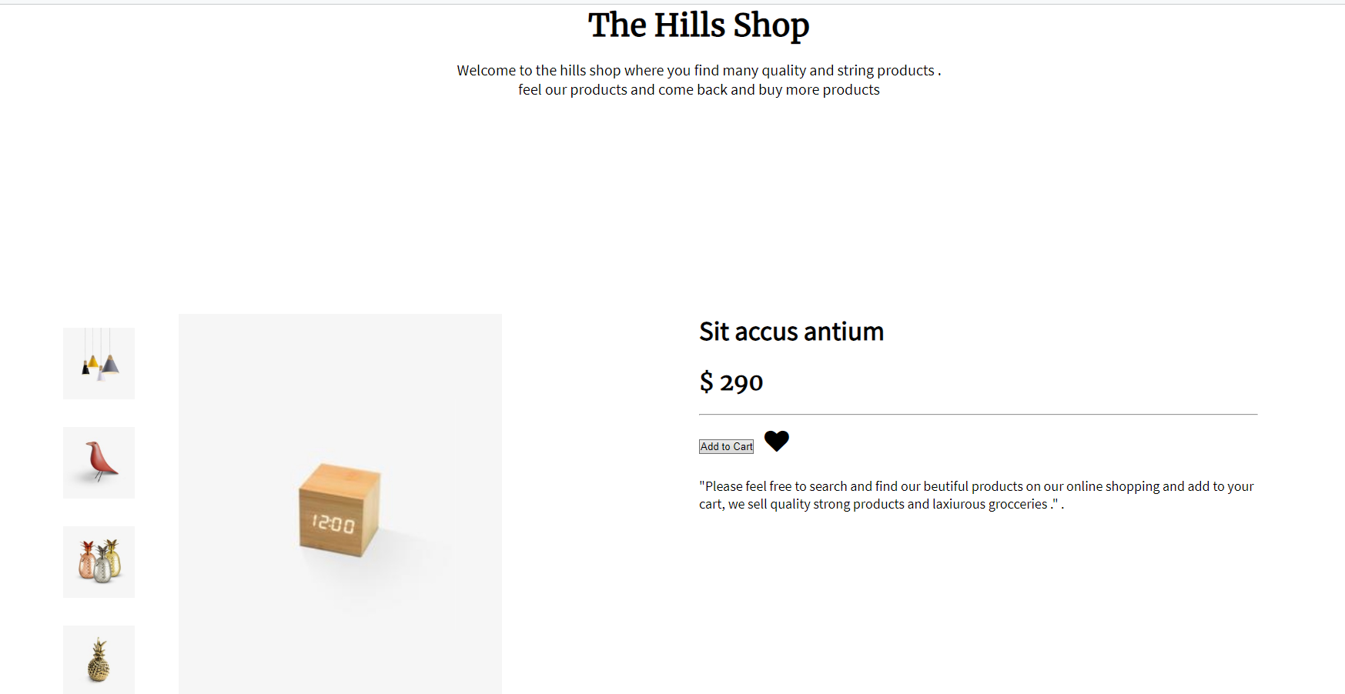

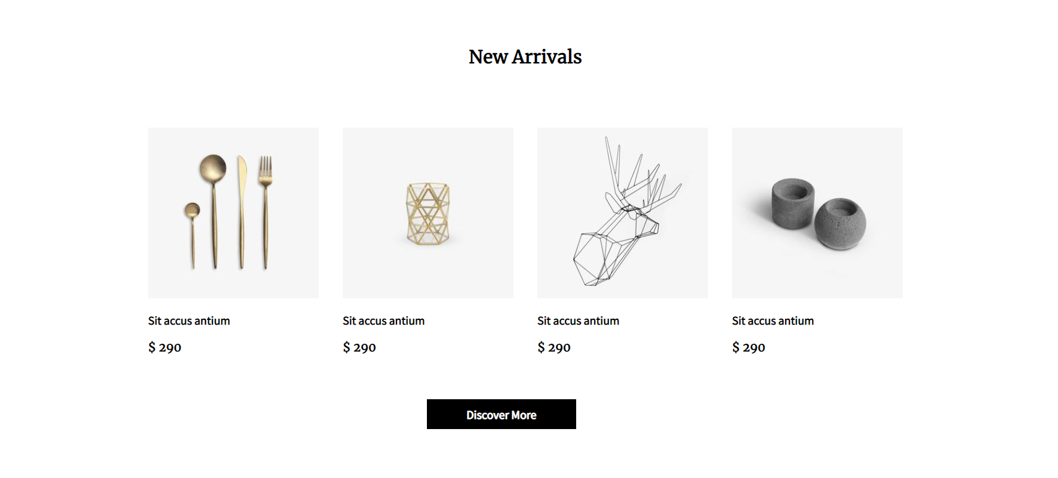



* Then came the shop:

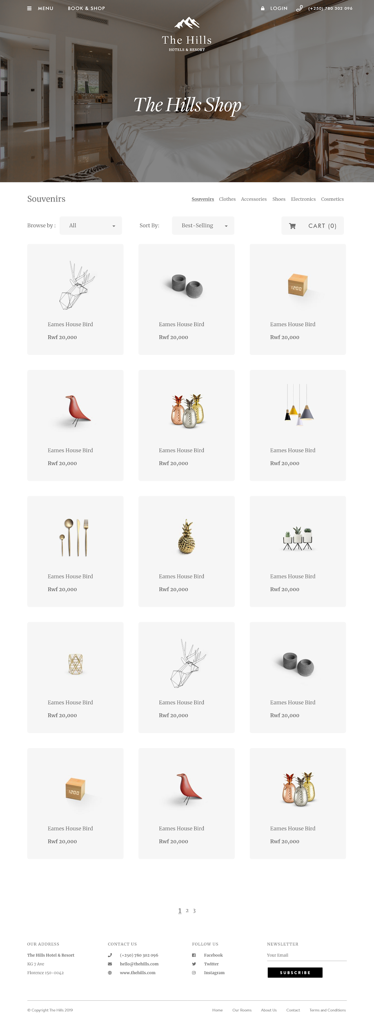

* Below is an image of the database used to implement the user interface of the shop:

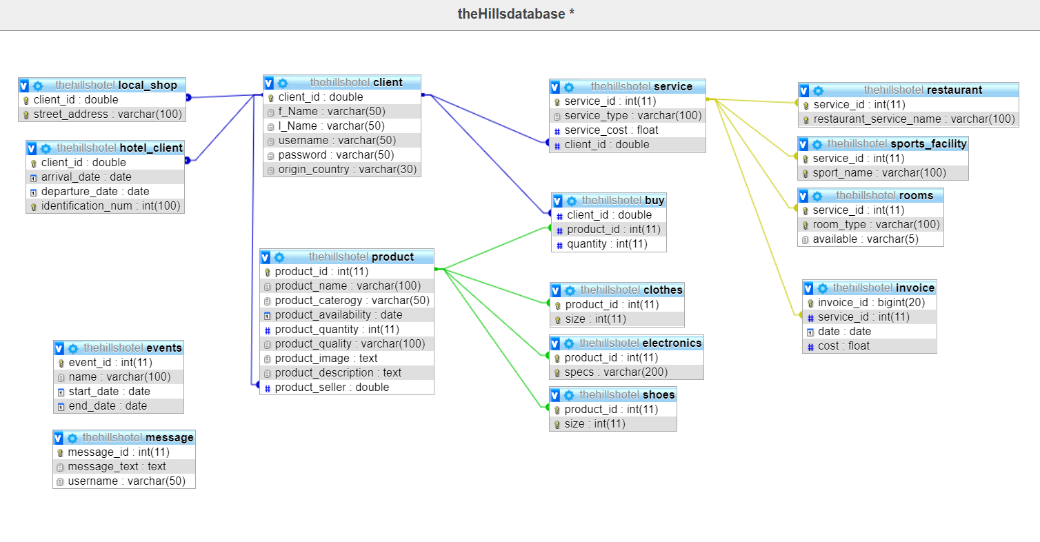

**EXECUTIVE SUMMARY**

In implementing the project, the work was divided into two parts:

1. **The Front End**

The programming languages that we heavily relied on were HTML, CSS and Javascript.

Design played a great role in ensuring that the front end was presentable and aesthetically pleasing. In this section, we had to ensure that the separate pages required to make a complete website were first finished. These pages include; the home page, the gallery, booking page, ga

1. **The Back End**

In this section, we went back to our teachings from Databases and implemented tackled the database behind the website. Ensuring that customers, once on the website, are able to log into their given accounts, book rooms and and have their requests logged and saved into a database system. In addition to this, the shop, a great aspect of the project, required to be user interactive such that the buyer and seller could easily interact and agree on sales of products posted. There exists local clients and foreign clients both of which want and need to have different products purchased after being advertised. All this is catered for through the back end.

The main programming language used here was php in alignment with MySQL.

Put together, below is the description of what the website is able to accomplish:

* Enable foreigners as well as local clients to reserve rooms for accommodation at their desired period of time.
* Inform potential clients; whether local or foreign of the available space/rooms for holding conferences and other business oriented events.
* Show upcoming as well as passed events/ activities/ promotions available.
* Create an online market for both foreigners and local shops to buy and sell their antiques and other products for easier accessibility.
* Create accounts for clients who wish to engage in the selling and buying of products.
* Description on the products including but not limited to the inventory/availability, quality and pricing.

**SCOPE OF TESTING**

* The following tests were carried out:
  + Functionality Test
    - We tested the links on each page such that when one clicks on the About Us link on the Homepage, they are able to access it.
    - The forms were also tested. One is able to book rooms by filling in the form and be directed accordingly.
  + Security Test
    - We tested this by pasting internal URL directly into the browser address bar without login. Internal pages should not open and they did not.
    - We also tried some invalid inputs in input fields like login username, password, input text boxes. We checked the system's reaction to all invalid inputs and found them to be satisfactory.
    - Web directories or files should not be accessible directly unless they are given download option.
  + Performance Test
    - Web **load testing**: Here we tested if many users are accessing or requesting the same page. The site should b able to handle many simultaneous user requests, large input data from users, simultaneous connection to the database as well as heavy load on specific pages
    - **Web Stress testing:** We performed this to break the site by giving stress and its checked as for how the system reacts to stress and how it recovers from crashes. Stress is generally given on input fields, login and sign up areas.
  + Interface Test
    - We checked is the interactions between the servers are executed and the errors are handled properly. No query returns an error message and should there be an error on the side of the user, error messages are displayed appropriately.
    - We also checked to see what happens if the user interrupts any transaction in-between. Does it stop? Does it run from the process again from the beginning?

**OUT OF SCOPE**

* In the shop, we did not test to ensure that the cart becomes updated when one purchases an item or increases the quantity/saved products.

**RECOMMENDATIONS**

* Updating new products in the shop can be improved to be done with ease.
* Enabling users to subscribe for notifications and emails.